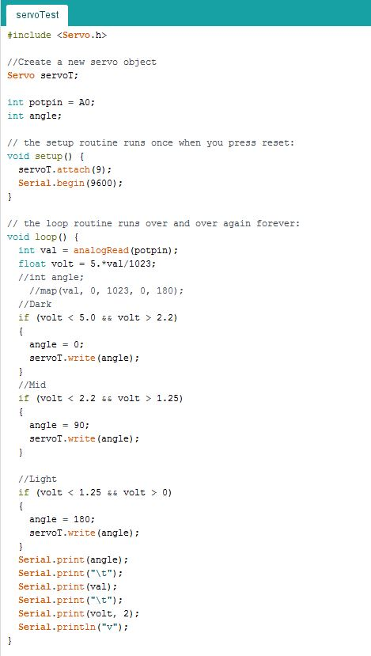

Servo test code

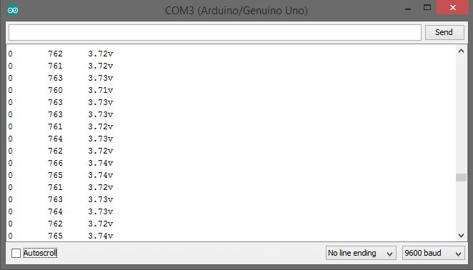

Serial monitor for low light servo test

Left: servo angle

Center: PR intensity

Right: Voltage when using 2k ohm resistors

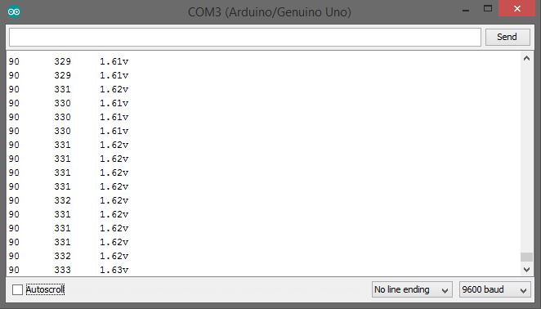

Serial monitor for medium light servo test

Left: servo angle

Center: PR intensity

Right: Voltage when using 2k ohm resistors

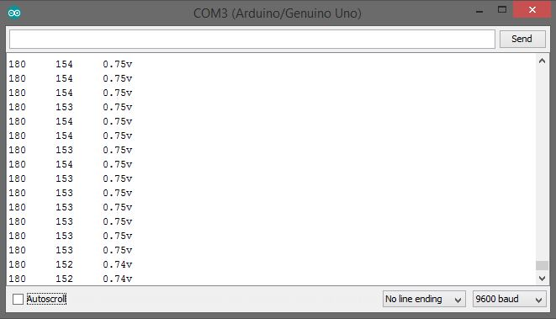

Serial monitor for high light servo test

Left: servo angle

Center: PR intensity

Right: Voltage when using 2k ohm resistors

\*\*\*\*\*\*\*

Voltage values represent fullness levels of a food bowl. Ideally LED lights will be placed in a bowl that will allow a photoresistor to tell how many lights are visible based the amount of voltage resisted. Ex: low voltage values would mean a high amount of light and thus an empty bowl.